CQC Compliance for Log360 Cloud
Ensure healthcare security and CQC compliance with Log360.
Region: Global | Type: Healthcare, Operational Resilience | Category: Compliance | Pricing: Free

Overview
The CQC compliance extension in Log360 helps organizations meet CQC Compliance, the Care Quality Commission's data security standards for health and social care providers in England underpinned by the National Data Guardian's 10 Data Security Standards and the DSPT by providing centralized log management, access auditing, and threat detection. The platform supports CQC requirements for personal confidential data handling, access control and audit attribution, cyber attack response, business continuity, and IT infrastructure security.
For Good Governance - Records Security (Regulation 17), Log360 monitors database DDL and DML auditing, file system changes, and cloud storage file activity to provide visibility across personal data stores and detect unauthorized record modifications. To address Personal Confidential Data Handling (NDG Standard 1), the platform monitors OneDrive sharing activities, SharePoint sharing activities, Exchange Online mail flow events, and cloud storage integration and third-party access reports to detect unauthorized data sharing or disclosure. The extension also supports Access Control and Audit Attribution (NDG Standard 4) by providing capabilities that monitors AD logon reports, Windows logon and failed logon events, Unix logon and access, MFA authentication, and Entra ID user logon activity to provide complete access attribution.

Key Features
- Cyber Attack Identification and Response (NDG Standard 6): Log360 monitors network device attack reports, network security reports, FireEye threat reports, Trend Micro events, Windows threat detection.
- Business Continuity Planning (NDG Standard 7): Log360 monitors Windows backup and restore events, backup and disaster recovery infrastructure, backup jobs.
- Unsupported Systems and Cyber Essentials (NDG Standards 8-9): Log360 monitors Windows software updates, Windows program inventory, application whitelisting, registry changes, and process tracking.
- Accountable Suppliers and Third-Party Oversight (NDG Standard 10): Log360 monitors AWS IAM activity, AWS user activity, cloud storage integration and third-party access, Salesforce setup audit trail, Entra ID application management.
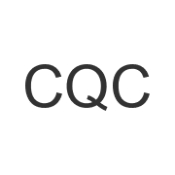
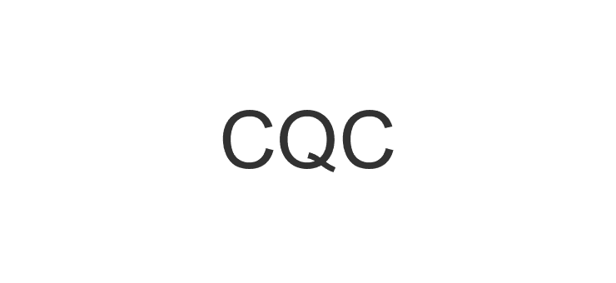
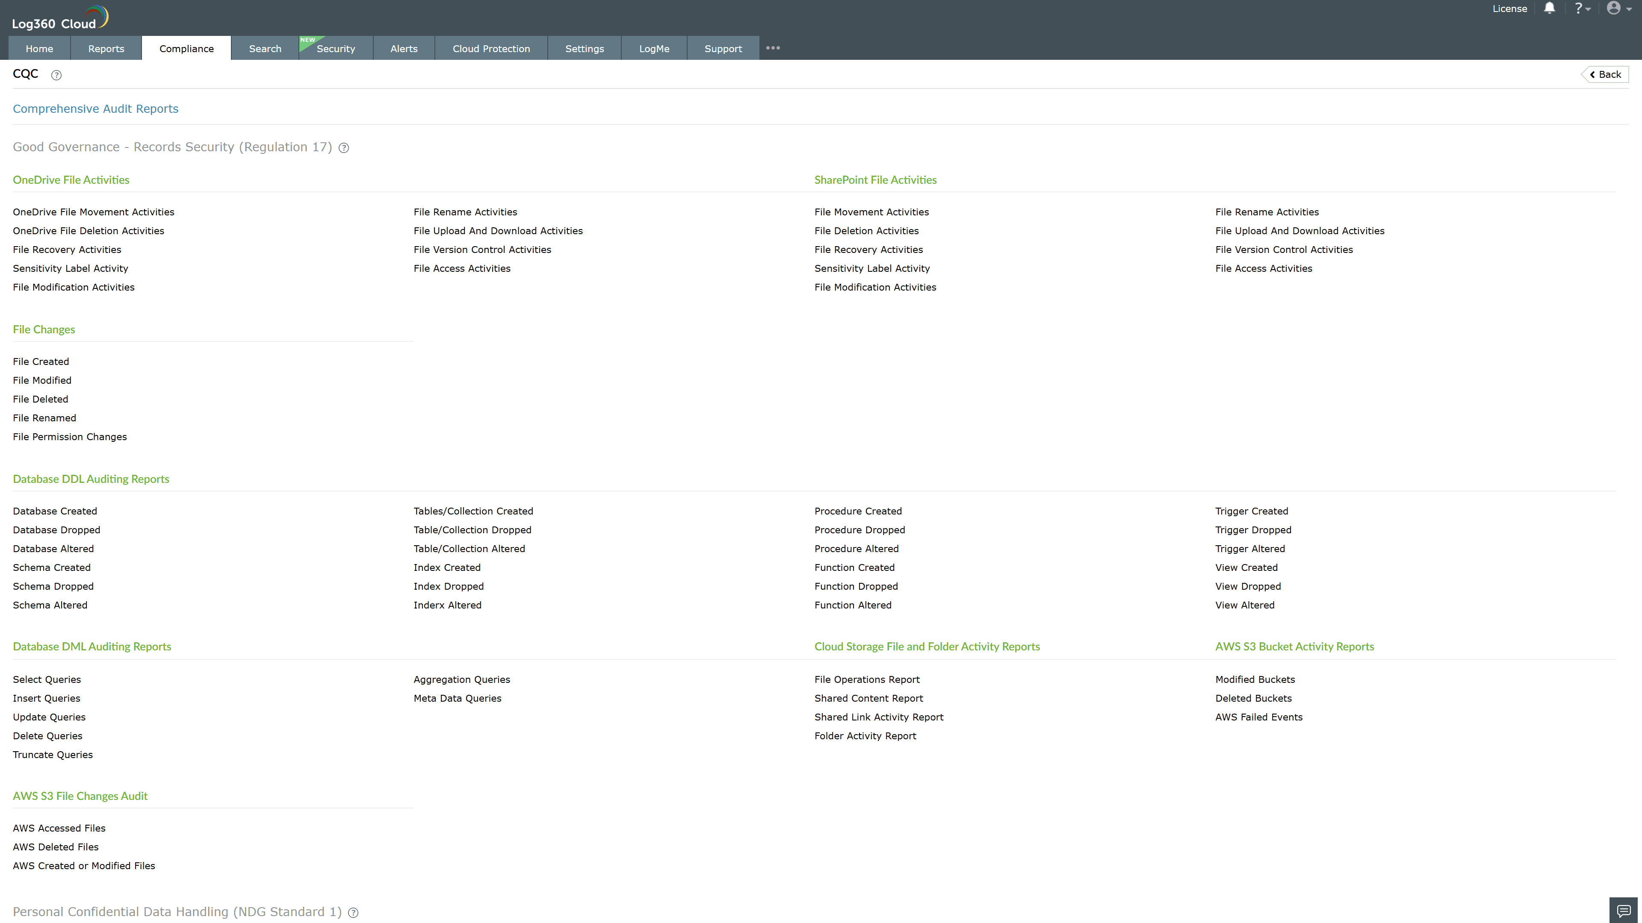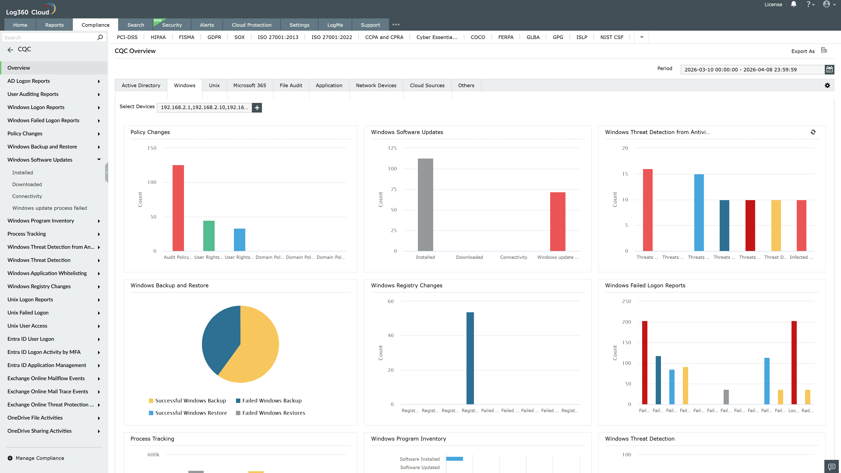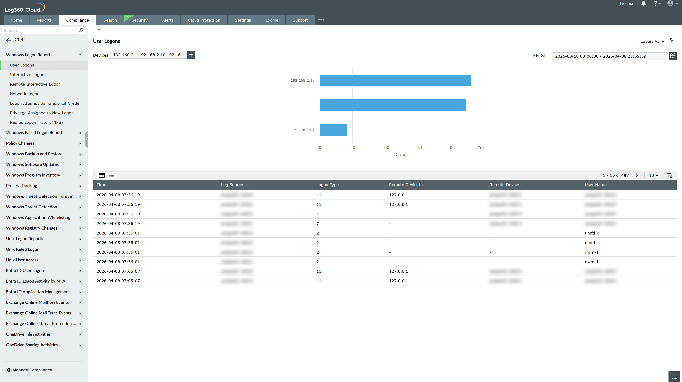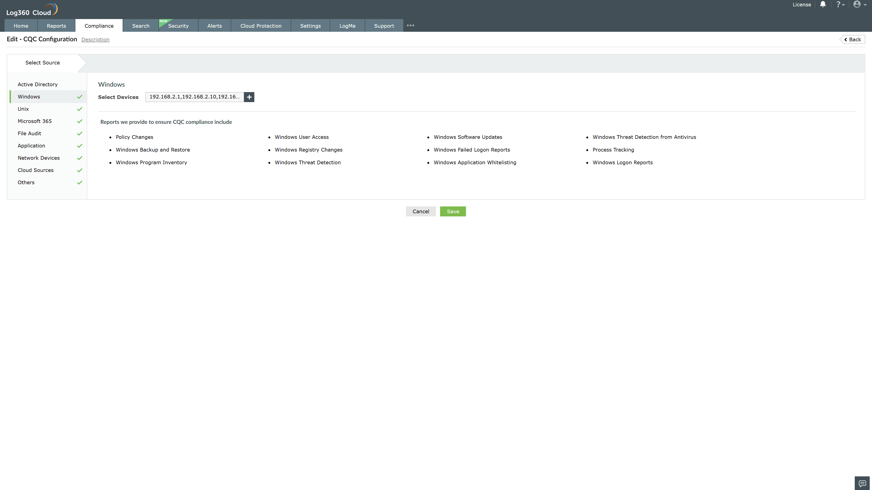

Valid Submission : Yes
Supported Editions : Free, Basic, Standard, Professional, MSSP
Help Document : https://www.manageengine.com/log-management/help/integrations/compliance-extensions.html
Help Video : Not provided
Tags : Log360, Compliance, Privacy monitoring, Data privacy, Regulatory compliance
Supported DCs : US, IN, JP, CA, AU, UK and EU
Privacy Policy:
Terms of Service:
Release Notes:
Predefined reports for the CQC.

